Press Release

Comet Media Foundation
Kiran Nadar Museum of Art
Jehangir Nicholson Art Foundation
present
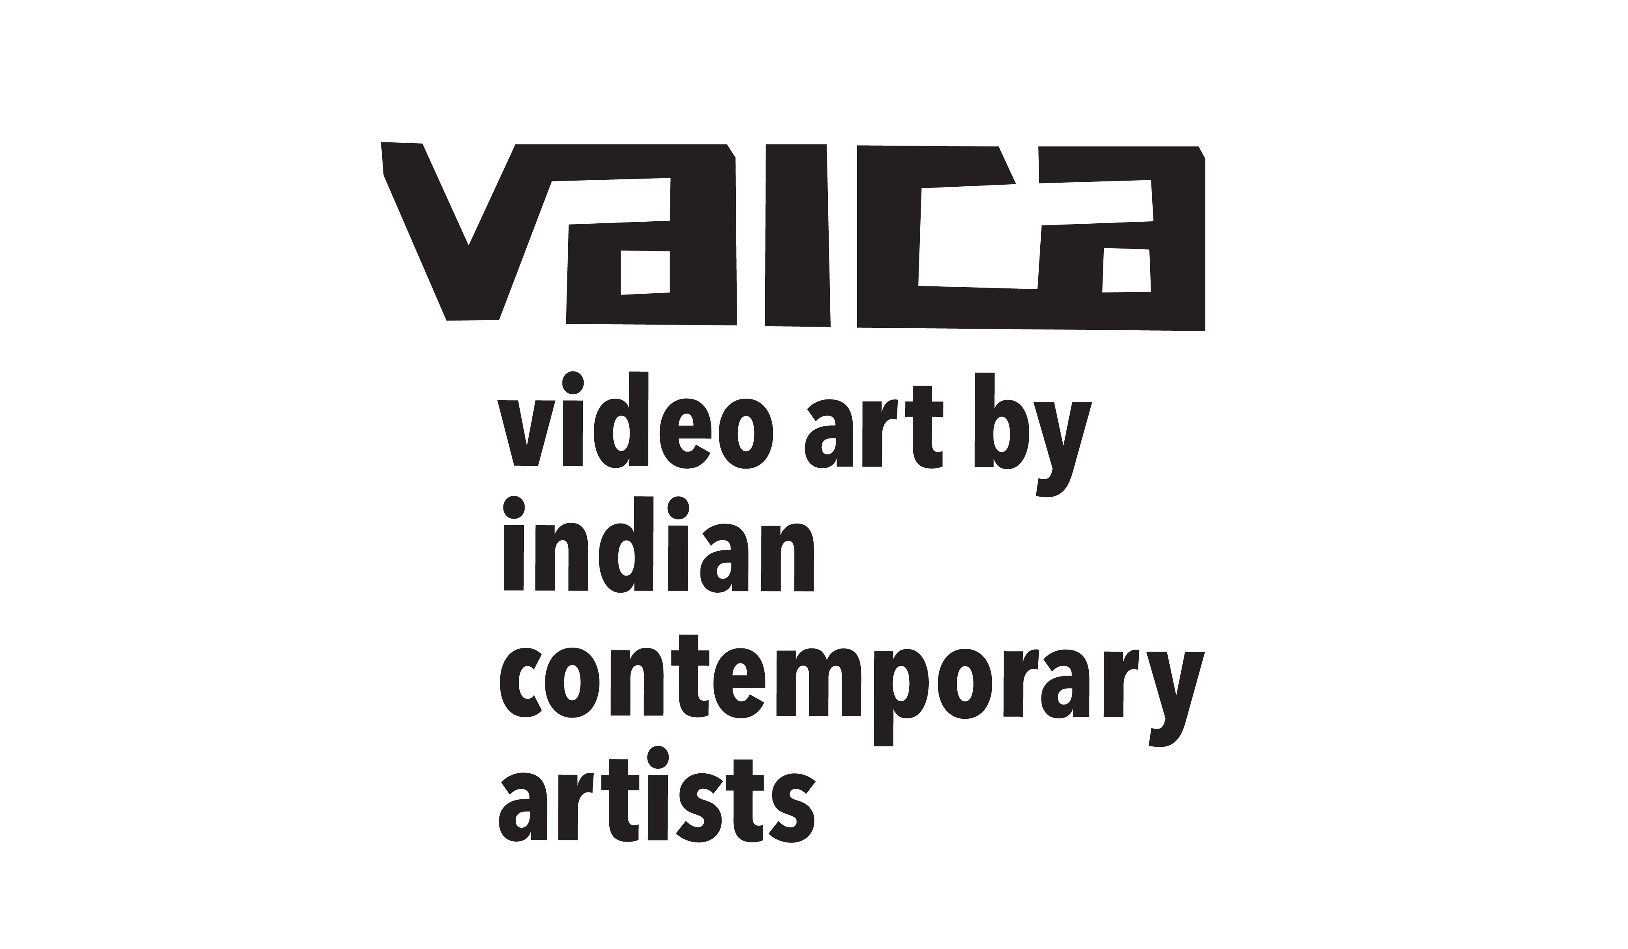
Curated by Bharati Kapadia and Chandita Mukherjee

Participating artists
Ansuman Chakraborty, Anuradha Upadhyay, Archana Hande, Atul Bhalla, BV Suresh, Babu Eshwar Prasad, Baptist Coelho, Bharati Kapadia, Darshana Vora, Gargi Raina, Hetal Chudasama, Jahangir Jani, Jeetin Rangher, Karthik KV, Khandakar Ohida, Manmeet Devgan, Meera Devidayal, Mithu Sen, Monali Meher, Muskaan Singh, Navjot Altaf, Paribartana Mohanty, Ranbir Kaleka, Ranu Mukherjee, Saba Hasan, Shakuntala Kulkarni, Sharmila Samant, Sumakshi Singh, Surekha, Tushar Joag, Veer Munshi, Vibha Ghalotra, Vidha Saumya, Vidya Kamat, Vijay Sekhon

Delhi Chapter of the festival
from 5:30 to 8 pm on 03, 04, 05 & 06 January, 2020
at Kiran Nadar Museum of Art
145, DLF South Court Mall, Saket District Centre, New Delhi 110017
with a unique sequence of video works on each occasion

Video art defies many of the conventions that define theatrical cinema. The curators of VAICA, the Festival of Video Art by Indian Contemporary Artists, aim to bring together audiences curious to engage with current developments in the arts. This three day festival is an attempt to offer exposure to a wide range of artists' videos, addressing varied issues, and giving a window on the vast possibilities that the idiom of video can offer to the artists’ imagination.

The festival features work from some of India’s foremost artists, some working with the medium for decades, like Ranbir Kaleka and Navjot Altaf. It includes artists like Shakuntala Kulkarni, Anuradha Upadhyay and Manmeet Devgun who have adopted the medium to engage with complex situations faced by women. Anshuman Chakraborty, Ranu Mukherjee, Sumakshi Singh and Archana Hande address vocabularies of visual art in their work whilst Tushar Joag, Sharmila Samant and Vidha Saumya critically engage with the realities of our social environment.

About the Curators
Bharati Kapadia:
Artist, graphic designer, art consultant and performer, Bharati Kapadia has been engaged with the visual arts in various capacities for over four decades. Her performances and video works have been shown widely in India and at venues in New York, Boston, Vienna, Munich and she has participated in residencies in India, US and Spain. As a graphic designer, she has designed books, catalogues, posters, executed turnkey exhibition projects. She has curated art exhibitions and has been an art consultant to several Indian art collectors.

Chandita Mukherjee
Chandita Mukherjee is a documentary film maker who has extensively explored the links between science, technology and society in her work. Her main interest is in the ways that people understand the world and act on it. She has produced films, organised learning festivals and conducted trainings, winning national and international recognition for her work.

For further information and to schedule interviews please contact:
Bharati Kapadia: bharatikapadia@gmail.com +91 83560 47479, +91 96993 26071
Chandita Mukherjee: chandita.mukherjee@gmil.com +91 98205 09179, +91 22 4973 5582

Images: please refer to the image in the press folder as shared with you

